SET 7 – CUSTOMER DEMOGRAPHICS ANALYSIS
Aim
To analyze customer demographics based on age, gender, and income using bar charts, pie charts, and a table in R.
Algorithm
- Create the customer demographic dataset.
- Store customer ID, age, gender, and income.
- Create a bar chart to represent customer ages.
- Create a pie chart to represent the distribution of customers by gender.
- Display the demographic information in a table.
- Add appropriate titles and labels.
R Program
library(ggplot2)

customer <- data.frame(
ID = c(1,2,3),
Age = c(28,35,42),
Gender = c("Female","Male","Female"),
Income = c(50000,60000,75000)
)

ggplot(customer, aes(factor(ID), Age)) +
geom_bar(stat="identity") +
labs(title="Customer Age Distribution",
x="Customer ID", y="Age") +
theme_minimal()

gender <- table(customer$Gender)

pie(gender,
main="Customer Distribution by Gender",
labels=paste(names(gender), gender))

print(customer)
output:
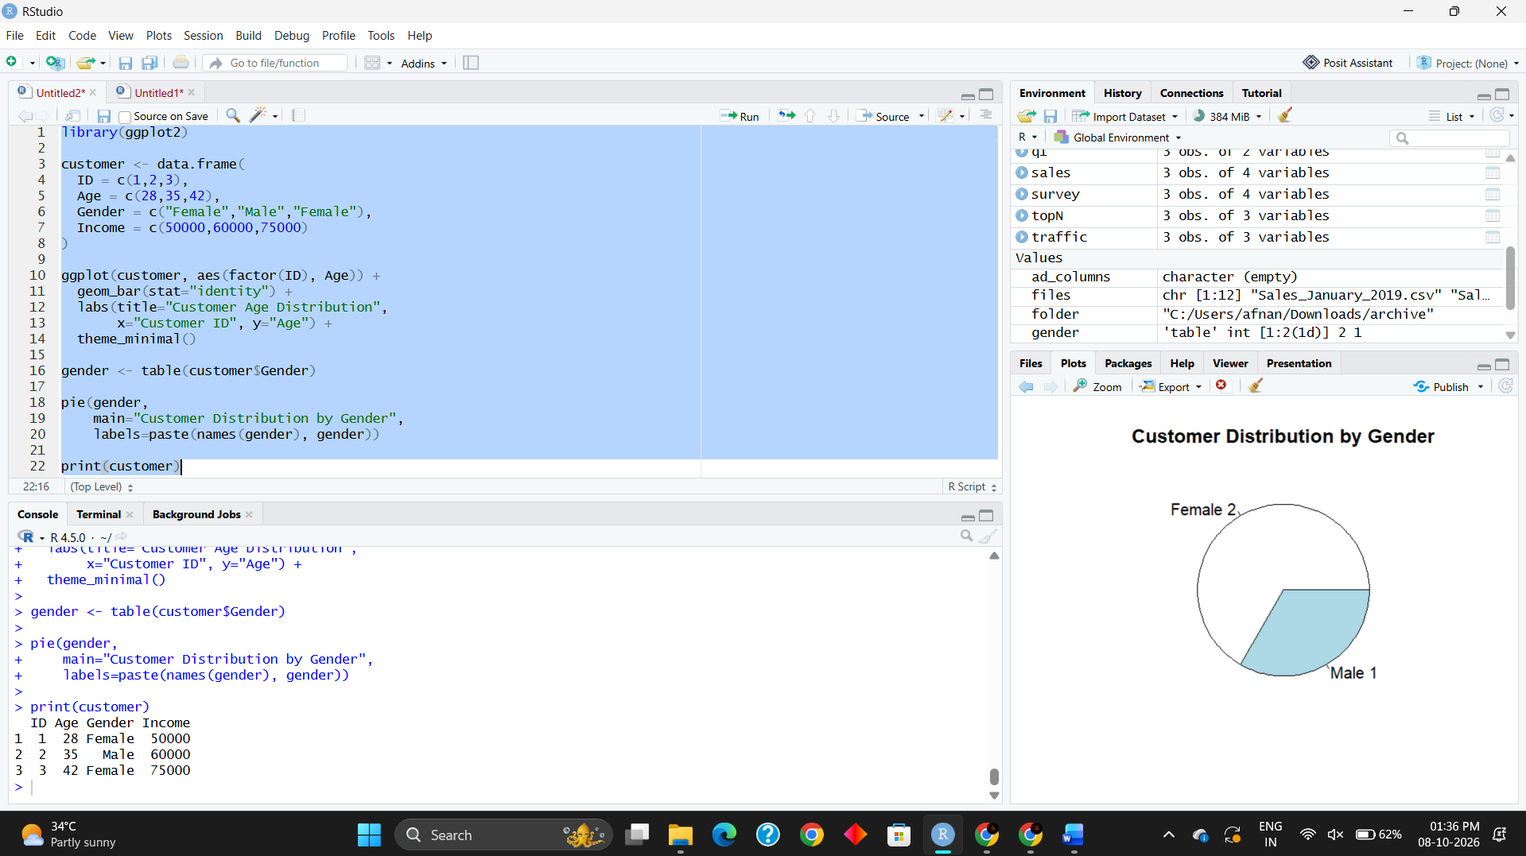
Result
The bar chart successfully represents the age of each customer. The pie chart shows the gender distribution, and the table displays the complete demographic information including customer ID, age, gender, and income.

